**Project Documentation:**

**Week 5 – Task:**

***Event-Booking System***

**Submitted By: Zara Khan**

**Submitted To: A&D Tech**

**Dated: 15th August, 2024**

**Main page:**

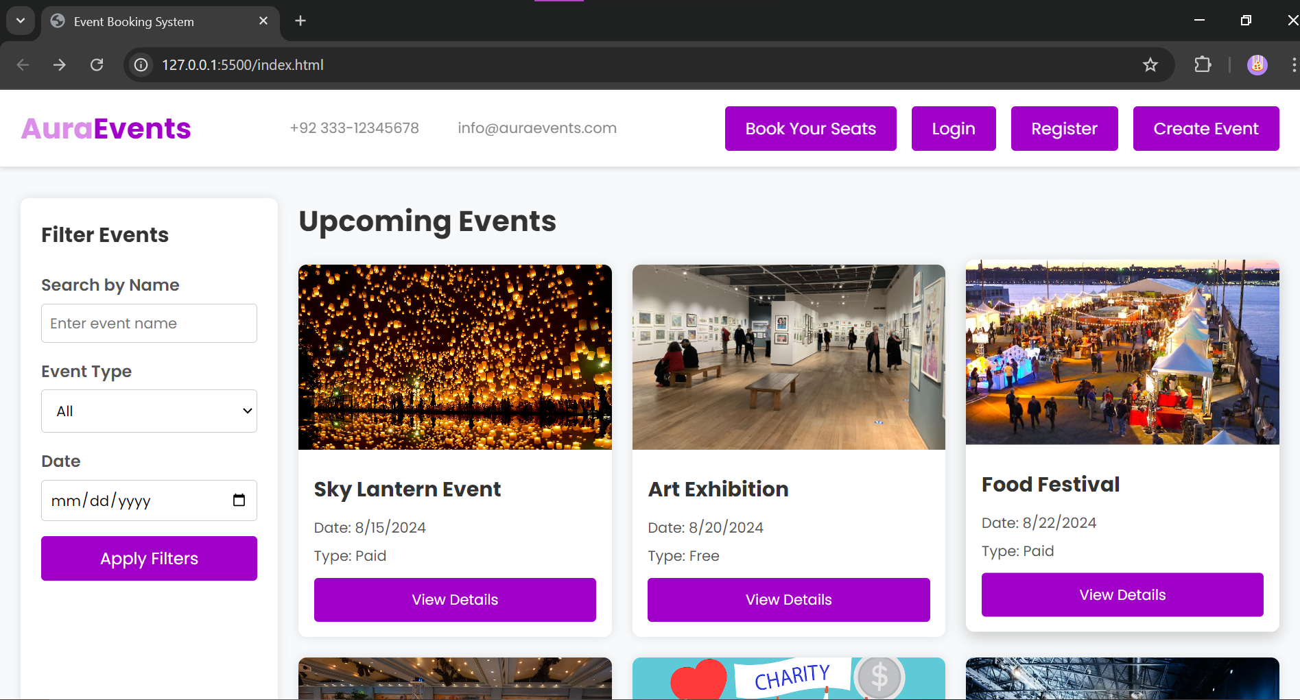

**Event-detail page:**

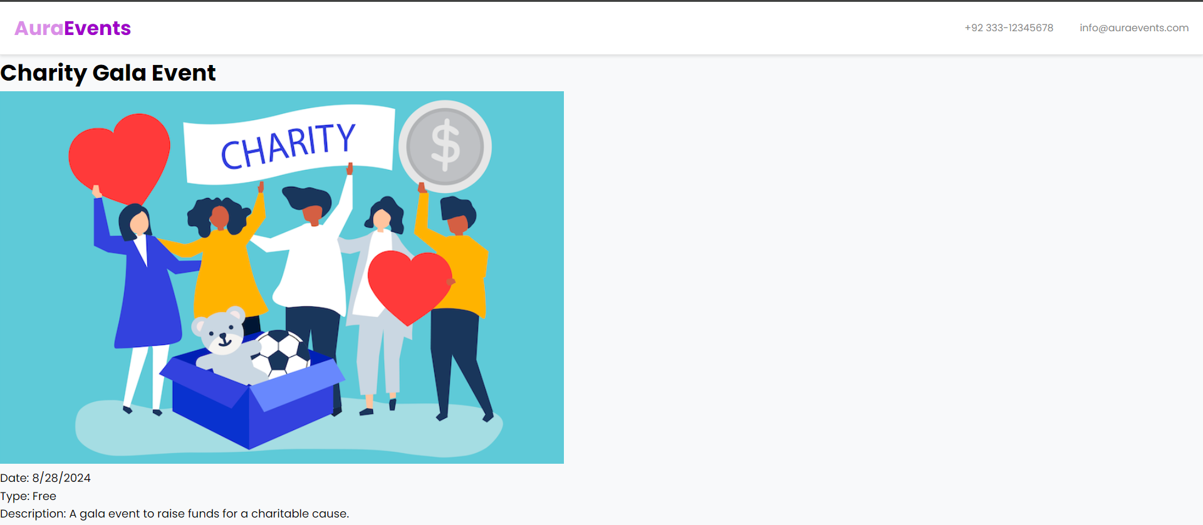

**Booking form:**

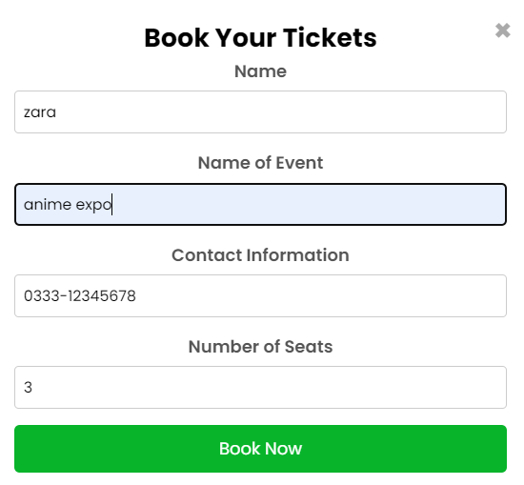

**Filters:**

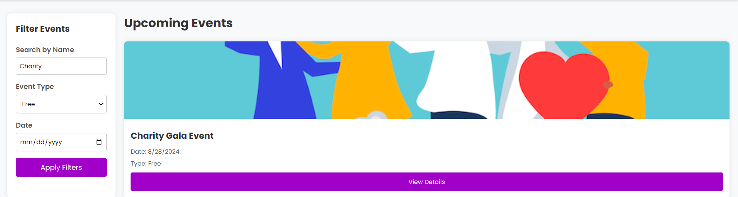

***Problem Statement***

Develop a comprehensive event booking system that allows users to view event listings, book tickets, and manage their bookings. This project will challenge your skills in form handling, state management, and user interface design, providing a robust application experience.

***Solution Overview***

I developed the event booking system by taking inspiration of the design from other websites. Added some events for demonstration purposes and used the filters to sort them using JavaScript. Then I added separate event-detail pages but used JavaScript to minimize the code by watching a tutorial. Lastly, I added the booking form and attached it to a button.

***Challenges and Resolutions***

**Challenge: Booking form**

* **Initial Issue**: Could not attach the booking form to the button
* **Approach & Resolution**: Watched some tutorials and used stack overflow.

***Instructions***

**Setting Up the Project**

1. **Download the Project Files:**
   * Clone the repository from GitHub.
   * Alternatively, download the project zip file and extract it to your local machine.
2. **Open in Visual Studio Code (VS Code):**
   * Launch VS Code.
   * Open the entire project folder using File > Open Folder.

**Running the Project**

1. **Navigate to the Main Page:**
   * In the VS Code sidebar, locate and open index.html.
2. **Viewing Events:**
   * Click on whatever event you want to see detail of. Use the booking form to see the booking seats feature.
3. **Testing Responsiveness:**
   * Use VS Code's built-in preview or open the website in different browsers and devices to ensure responsiveness.